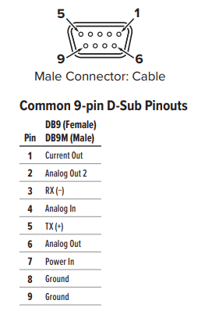

Pin 1 = Black

Pin 2 = Grey

Pin 3 = Red

Pin 4 = Green

Pin 5 = Brown

Pin 6 = Blue

Pin 7 = Orange

Pin 8 = Yellow

Pin 9 = Purple